Lab Guide

**Hardware Tests - Python**

# Content Description

The following document describes the hardware tests for the QCar in python or MATLAB software environments.

Content Description 1

MATLAB 1

Hardware Tests 1

Python 3

Hardware Tests 3

# MATLAB

## Hardware Tests

1. Use a charged battery to power the QCar platform.   
   **Note**: Check User Manual – Power for information on this.
2. Use a quick ping test to ensure that you are connected to the QCar platform.   
   **Note**: Check User Manual – Connectivity for setting up a remote Wi-Fi based connection with the QCar.
3. Run the individual hardware test models one at a time. Ensure that the IP address in the **MEX-file arguments** of the **Code Generation > Interface** tab of the **Model Configuration Settings** matches that of your platform.   
   **Note**: Check User Manual – Software Simulink for information on how to configure and deploy Simulink models to the QCar target.
4. The expected behaviour is as follows:   
   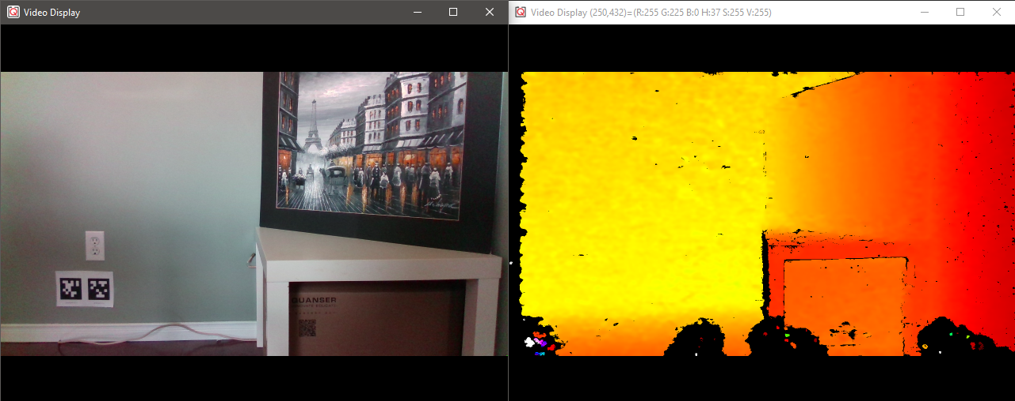
   1. Intel_Realsense.slx  
      This model should launch an RGB and Depth video display on your screen. An example output is shown here (RGB on left, Depth on right).  
         
      If your depth display looks monotonous, try reducing the **Maximum pixel value** parameter in the **Image Transform** block inside the **depthDisplay** subsystem.
   2. CSI_Cameras.slx   
      This model should display one CSI image in a video display on your screen depending on the camera ID constant (0 to 3) in the model’s root level. A sample output is shown below (in order, 0 - right, 1 - rear, 2 - left and 3 - front camera).

|  |  |
| --- | --- |
| A picture containing indoor, floor, wall  Description automatically generated 0 | 1 |
| 2 | 3 |

* 1. RP_LIDAR_A2.slx  
     This model should display a polar plot of the LIDAR scans. A sample output is shown here. Note that the 0 degree mark corresponds to the front of the vehicle, and the data is scanned in a counterclockwise positive direction.

* 1. Basic_IO.slx  
     This model should let you command the throttle and steering motors and write high (**1**) or low (**0**) values to the 8 LEDs. In addition, you can also read the motor current, battery voltage and motor speed. You should see the wheels spin forwards for a positive throttle, and the front wheels steer towards the left for a positive steering (resulting in counterclockwise rotation).

# Python

## Hardware Tests

1. Use a charged battery to power the QCar platform.   
     
   **Note**: Check User Manual – Power for information on this.
2. Use a quick ping test to ensure that you are connected to the QCar platform.   
     
   **Note**: Check User Manual – Connectivity for setting up a remote Wi-Fi based connection with the QCar.
3. Deploy the hardware test scripts on the QCar one at a time.   
     
   **Note**: Check User Manual – Software Python for information on how to deploy python applications to the QCar target.
4. The expected behaviour is as follows:   
   1. hardware_tests_intelrealsense.py  
      This script should launch an RGB and Depth window on your screen. An example output is shown here (RGB on left, Depth on right).

* 1. hardware_tests_csi_cameras.py   
     This script should display images from all CSI cameras in multiple windows on your screen. A sample output is shown below (in order, 0 - right, 1 - rear, 2 - left and 3 - front camera).

|  |  |
| --- | --- |
| A picture containing indoor, floor, wall  Description automatically generated 0 | 1 |
| A picture containing indoor, floor  Description automatically generated 2 | A picture containing indoor  Description automatically generated 3 |

* 1. hardware_test_rp_lidar_a2.py

This application should display a polar plot of the LIDAR scans. A sample output is shown here. Note that the 0 degree mark corresponds to the left of the vehicle which is the lidar frame, and the data is scanned in a counterclockwise positive direction.   
  
**Note**: Don’t forget to use the sudo flag when calling this script!

* 1. hardware_test_basic_io.py  
     This script should automatically drive a sinusoidal throttle and steering command to the wheels. As the steering changes left and right, the corresponding LED indicators should light up. As the wheels spin forward or backwards, the corresponding headlamps or rear lamps/reverse indicators should light up.

**Note**: Don’t forget to use the **sudo** flag when calling this script. Use the provided stand to elevate the QCar while performing the Basic_IO test.

* 1. hardware_test_gamepad.py  
     This script initializes and reads the Joystick - **Logitech Gamepad F710**. Plug the gamepad’s USB dongle into one of the USB ports on the QCar. Make sure the controller number within the **gamepadViaTarget()** is 1 unless there are more than one USB dongle being plugged in.